Assignment - 6

**Q1.** Algorithm for evaluating an expression using a tree.

Let t be the expression tree

If t is not null then

If t.value is operand then

Return t.value

A = solve(t.left)

B = solve(t.right)

// calculate applies operator 't.value'

// on A and B, and returns value

Return calculate(A, B, t.value)

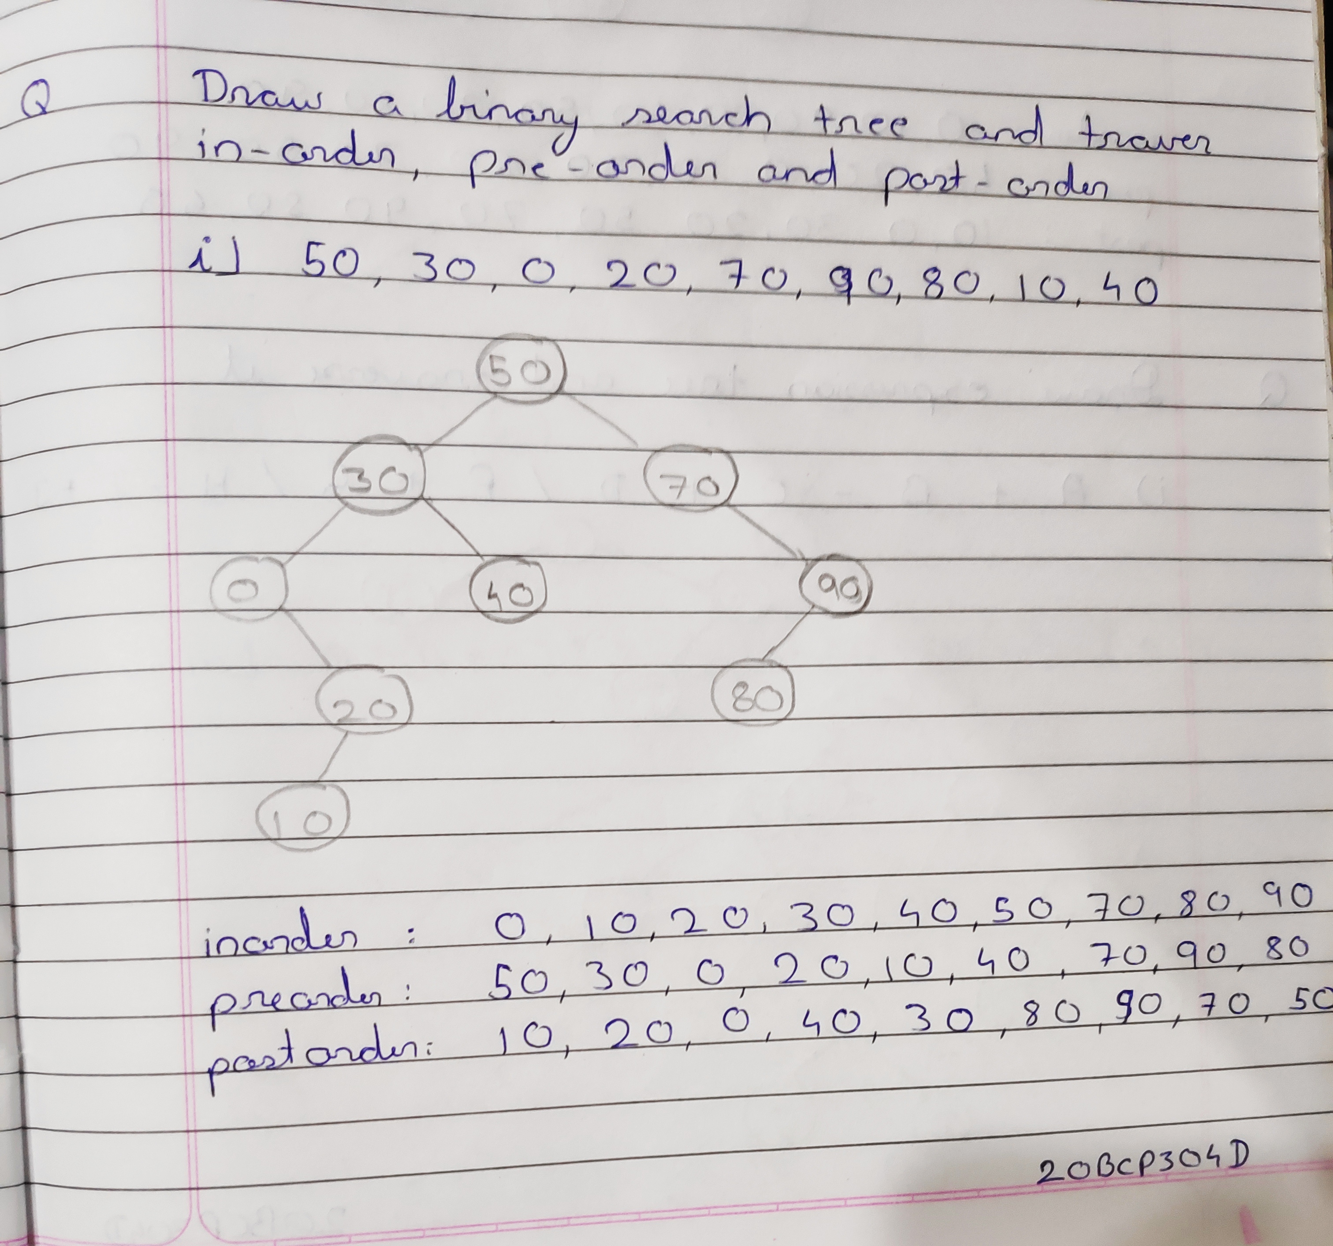

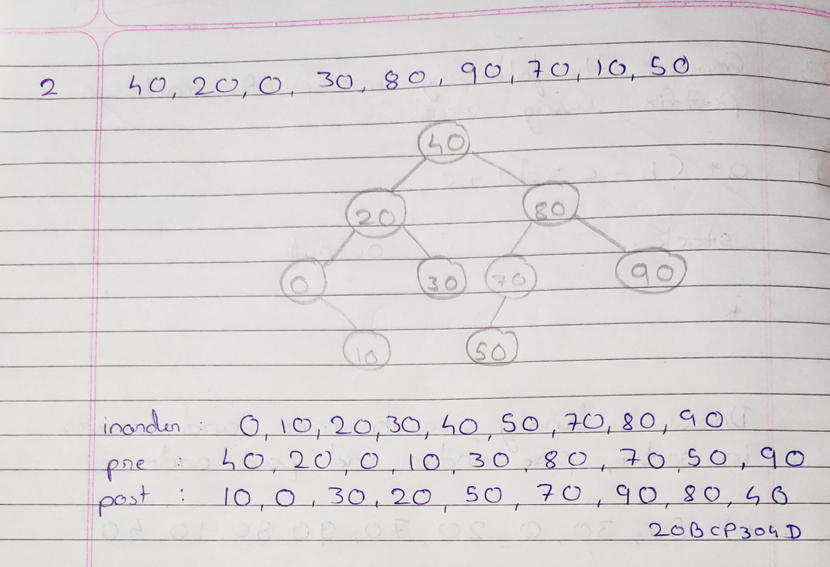

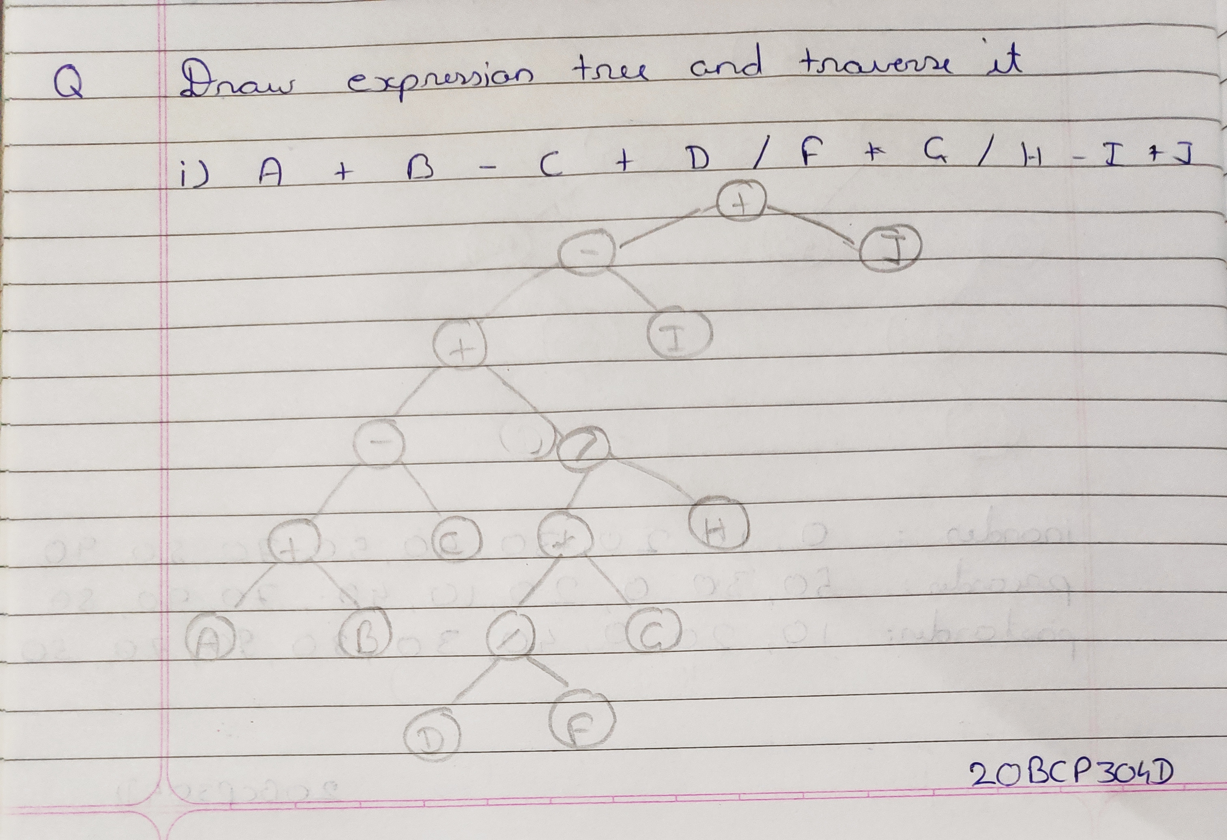

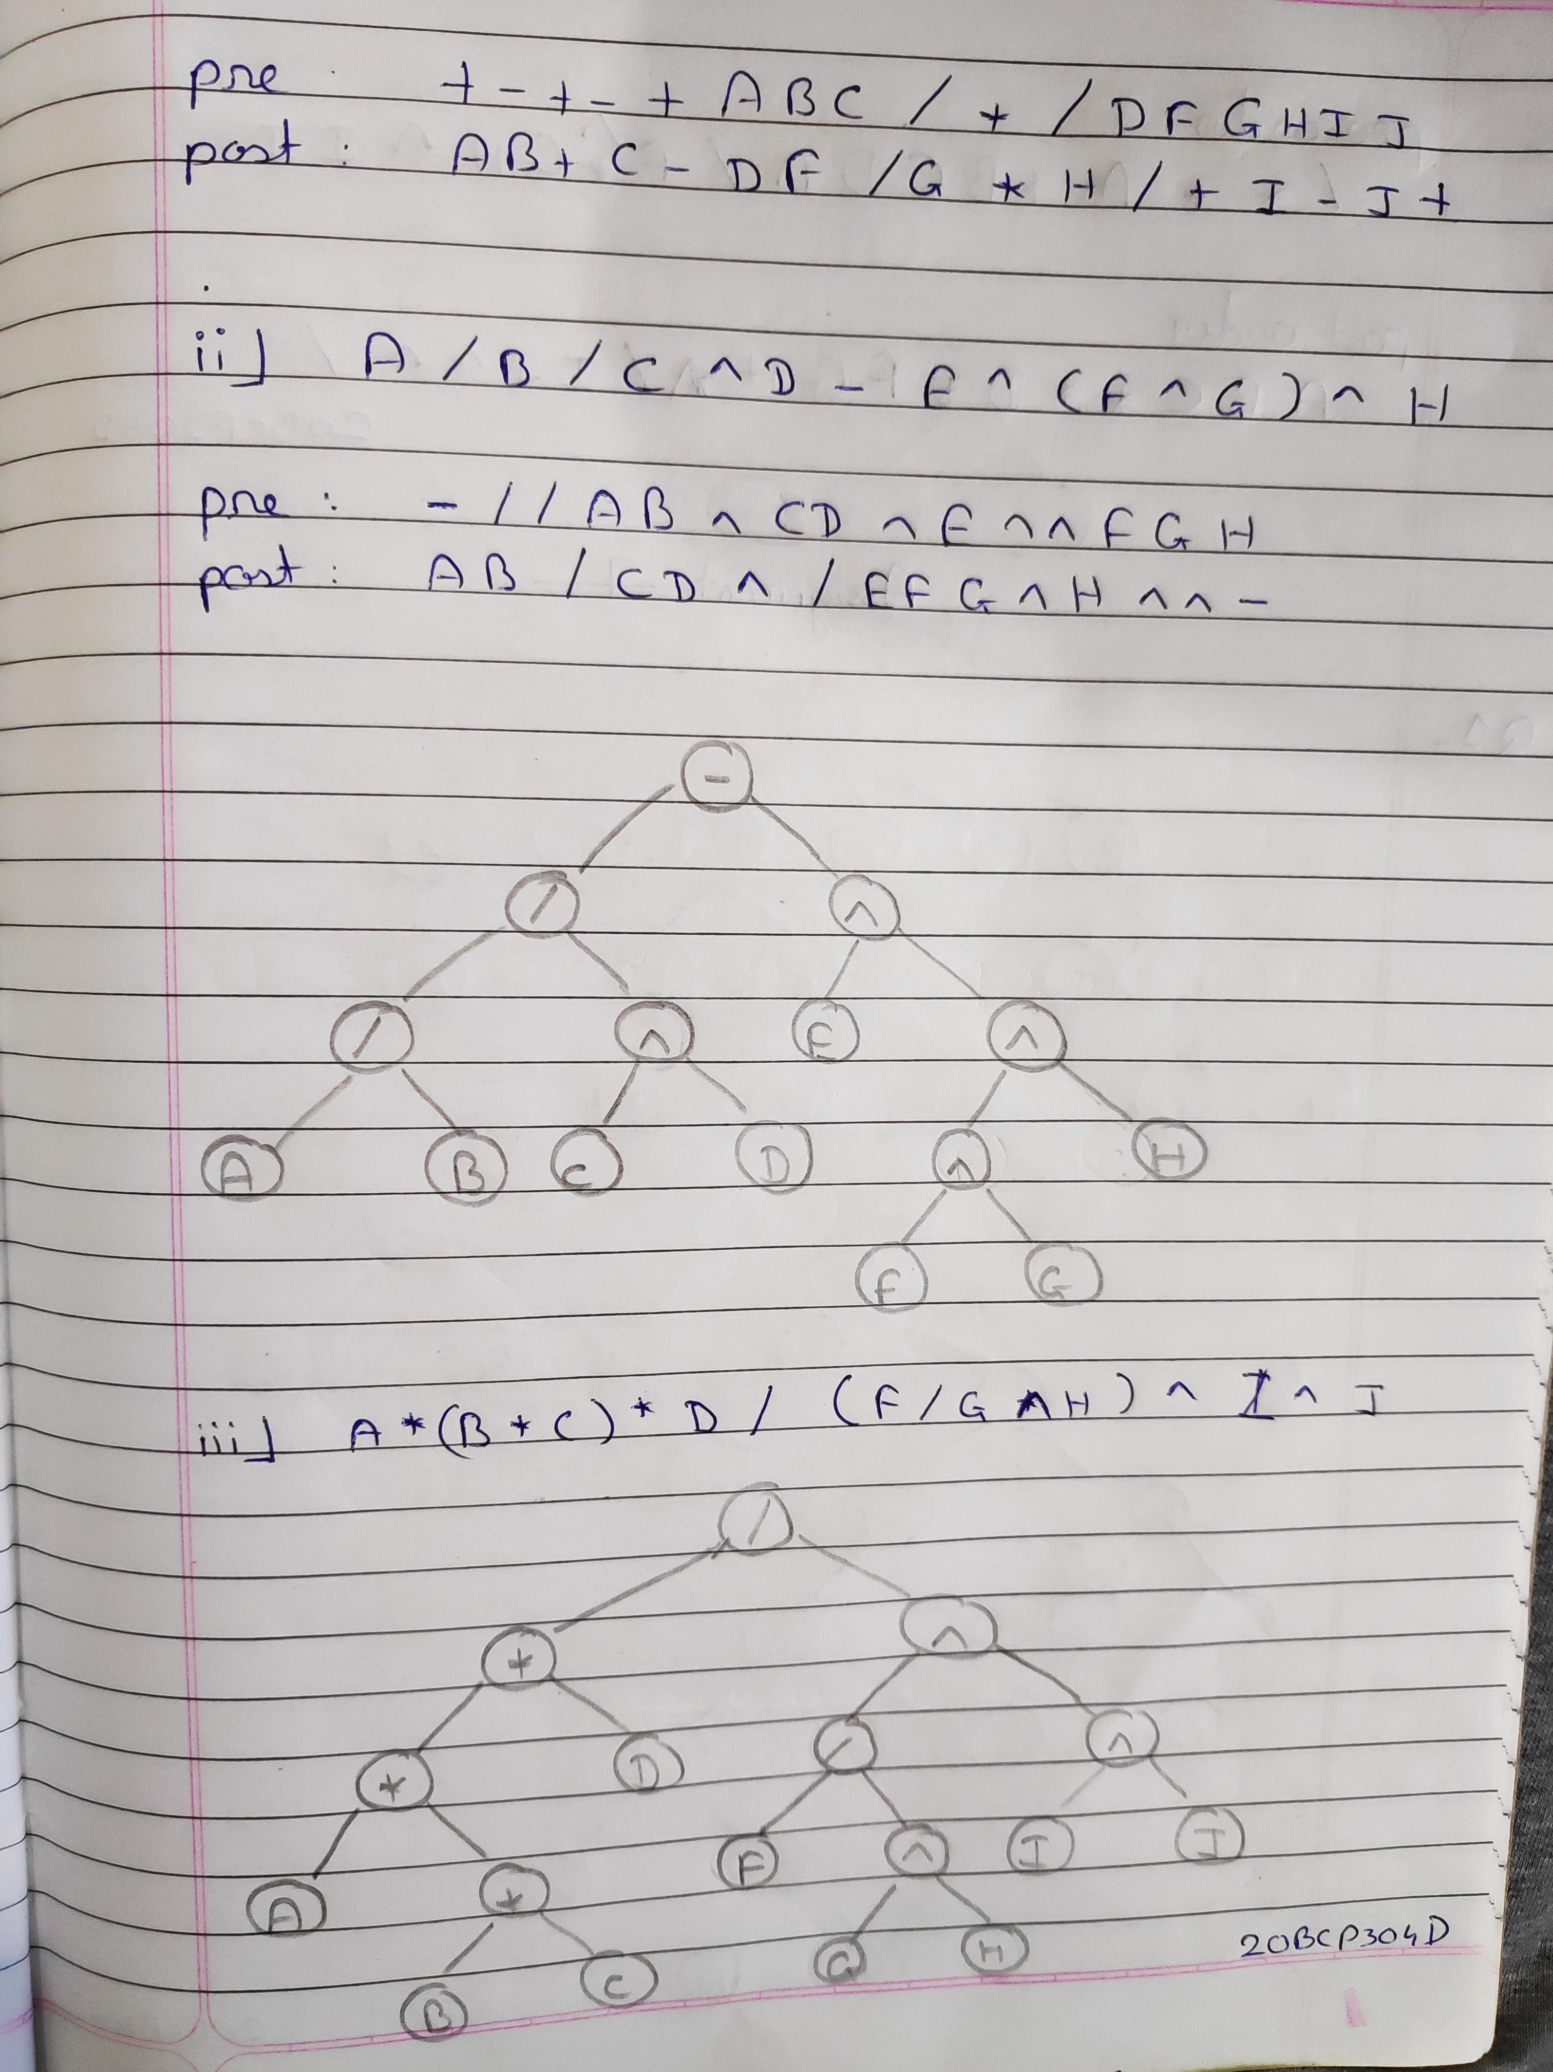

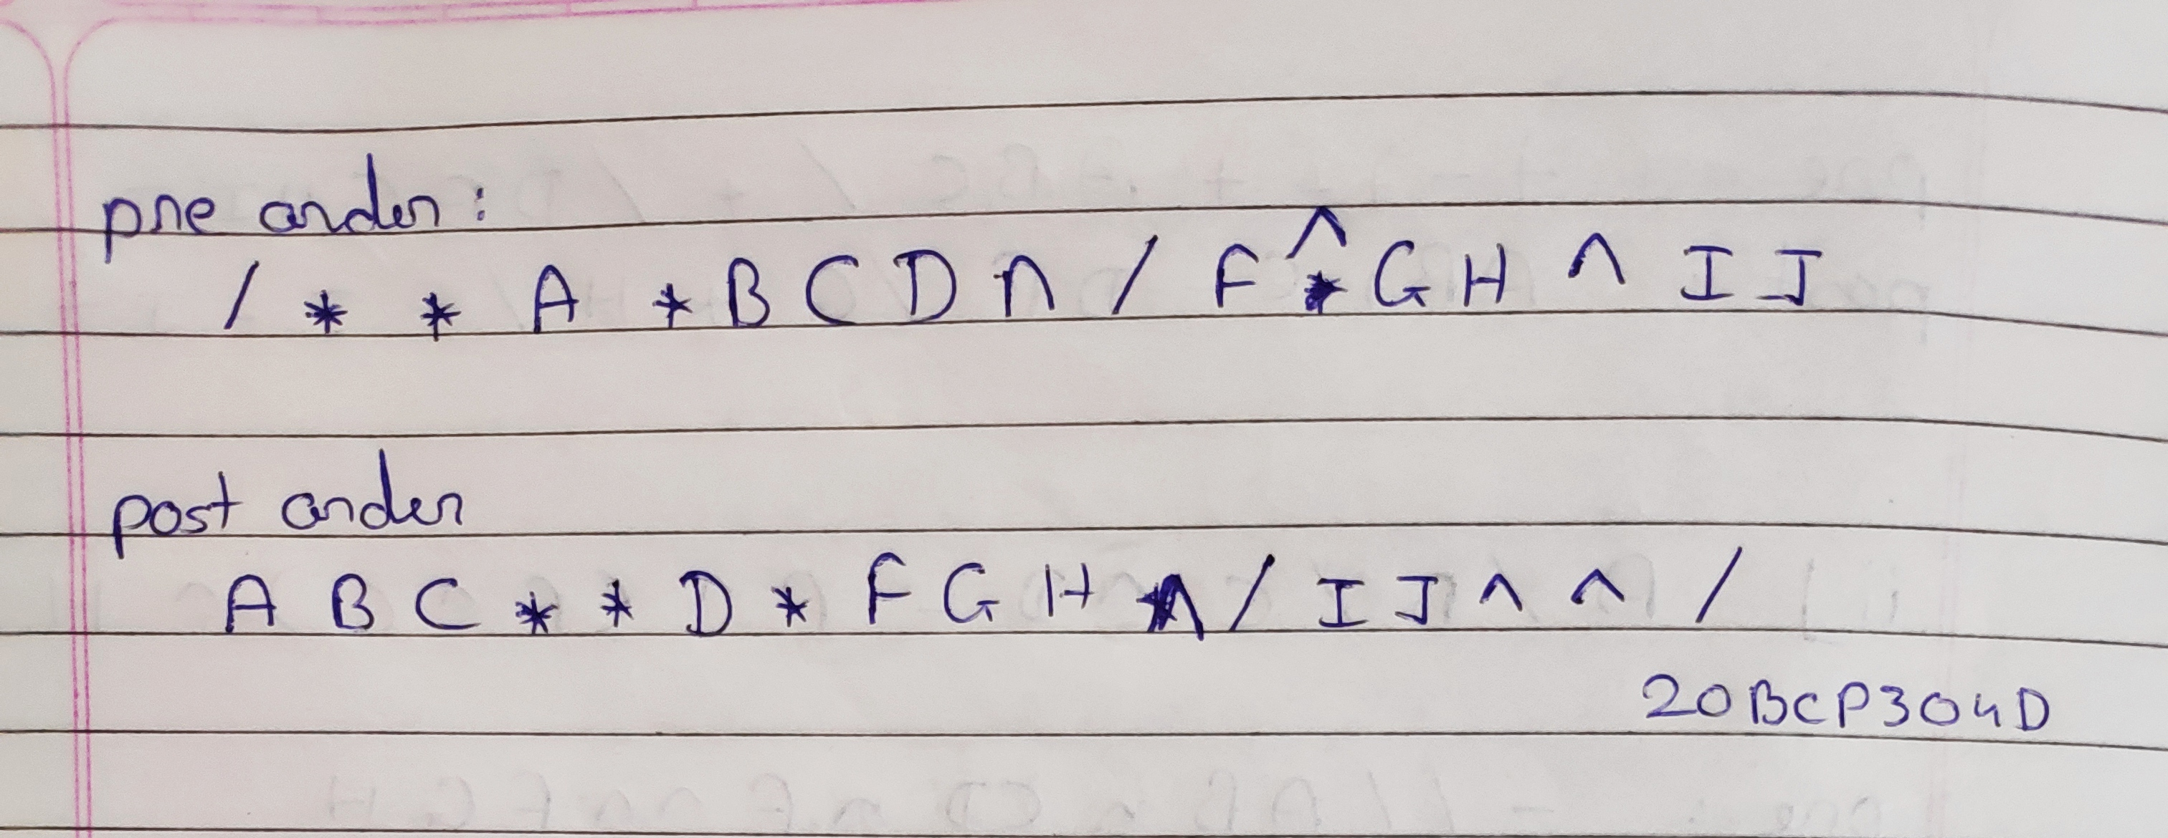

**Q4.**

